Task 2:

1. Retrieve all students' information and sort by grade in descending order:

Output:

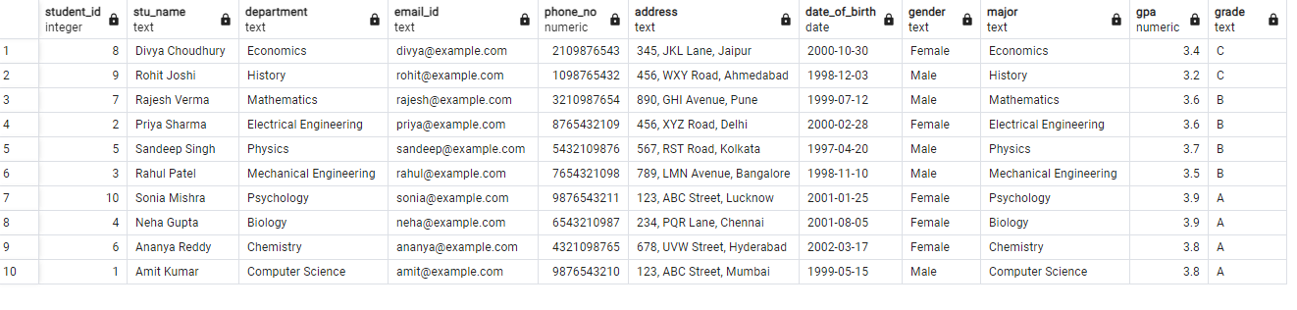

1. Query for Male Students:

Ouput:

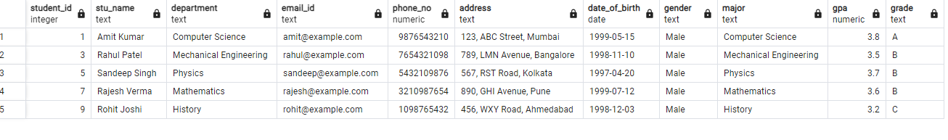

1. Query for Students with GPA less than 5.0:

Ouput :

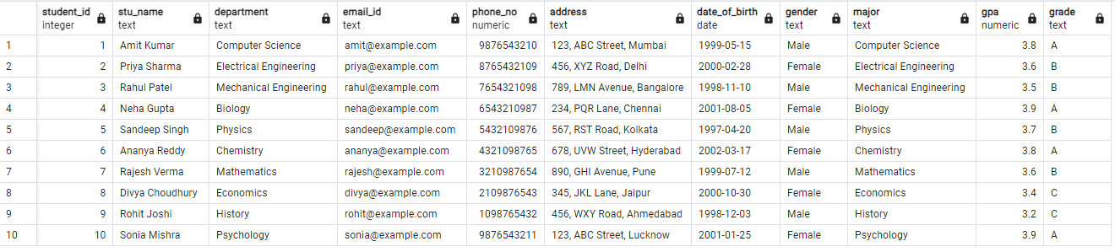

Query for Students with Grade "B"

Output :

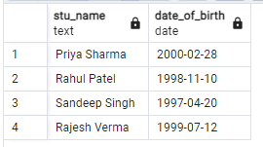

Grouping and Calculation (Average GPA by Department and Gender):

Output:

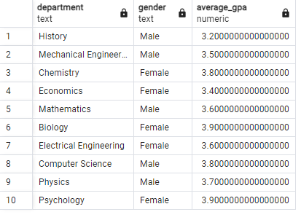

Retrieve Student with Highest GPA:

Output :

